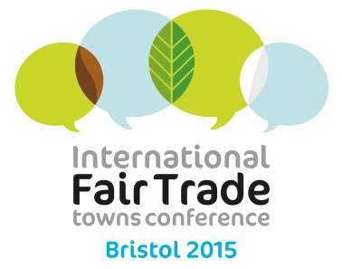
International Fair Trade Towns Conference Bristol resolution 2015

I, mayor of ………………………….……………
stress the need for communities around the world to embrace sustainable ways of living, consuming and trading, in full respect of the planet’s boundaries and the peoples' rights. Social concerns cannot be dissociated from environmental ones. Instead, a coherent approach to sustainable development is urgently needed that promote local solutions to global challenges;
consider 2015 a crucial year in which the international community will set itself important objectives in terms of poverty reduction and environmental commitments in a new, integrated sustainable development framework to replace the current Millennium Development Goals: The Sustainable Development Goals (SDGs).
believe international trade rules should be reformed to be more equitable and participatory, so that all actors impacted, especially poor farmers and workers across developing countries, are able to decide on the basis of the impacts that trade deals and other decisions will have on them.
acknowledge that climate change is a major challenge to humanity, in particular for farmers and workers whose livelihoods and ability to plan ahead are affected by climate change. In this context, Fair Trade plays a key role in supporting farmers to adapt to and mitigate against the negative consequences of climate change, such as droughts or pests.
call on national governments, the EU and the United Nations to use the adoption of the SDGs to place sustainable development at the heart of all areas of government policy from agriculture to trade, to ensure that different government policies are joined up and act as tools, not obstacles to achieving sustainable development objectives;
and to unlock the full potential of cities and regions to support Fair Trade to deliver the SDGs, through initiatives such as the European Fair Trade Capital Award to further encourage cities’ commitments in this field;
In the context of the implementation of the post-2015 Sustainable Development Goals, I commit to taking one step for Fair Trade before September 2016. My step will be:

………………………………………………………………………………………………………………………………………….

............................................................................................................................................

Signed ………………………………………………. Date …………….……………………………………

